**52 Kettlebell Exercises to Try Right Now  
BY GREG BROOKES**

There are lots of different kettlebell exercises that you can perform, some are more challenging than others.

You will find that there is a natural progression when it comes to training with certain kettle bell exercises so it is important to start at the beginning.

If you decide to jump to the more advanced kettlebell exercises without building up your fundamental skills first then your technique will suffer and there is a high chance of injury.

Here is a list of Kettle bell Exercises starting with the fundamental and most important at the top. Become skilled and proficient in each kettlebell exercise before moving on to the next. You can thank me for this later.

Kettlebell Slingshot

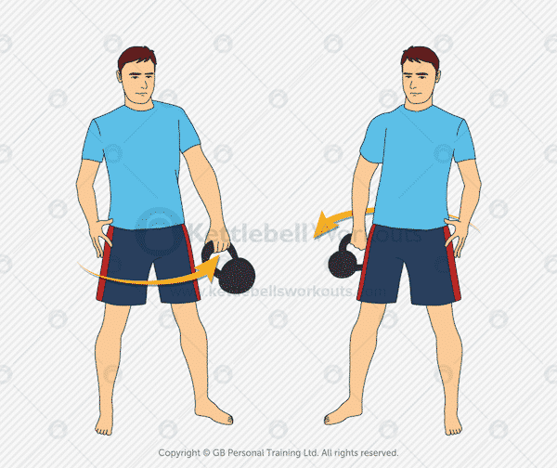  
Muscles used: Shoulders, Core  
Summary: Great warm up exercise that helps to acclimatize you to the kettlebell. Also, a good exercise to use as active recovery rather than resting between exercises.

Kettlebell Halo

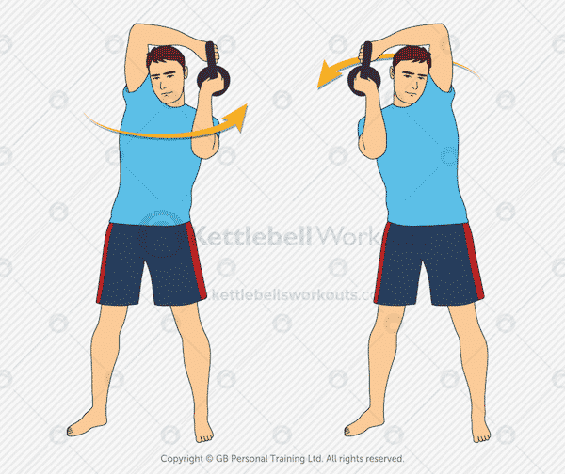

Muscles used: Shoulders  
Summary: Warm up your shoulder girdle, improve your shoulder mobility and strengthen your shoulders with this exercise.

Kettlebell Good Morning

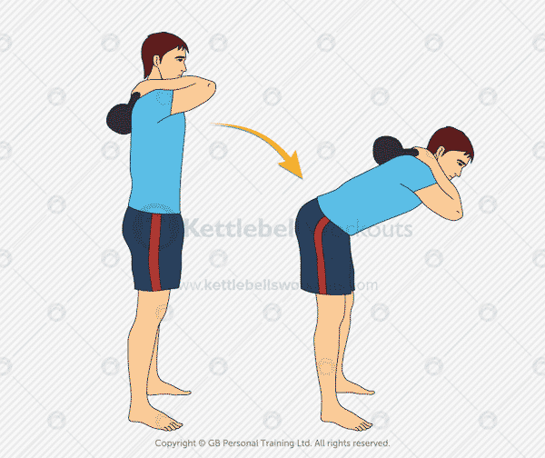

Muscles used: Glutes, Hamstrings  
Summary: Loosen up and strengthen your hamstrings with this kettlebell exercise. Be careful not to arch your lower back during this movement.

Kettlebell Single Arm Deadlift

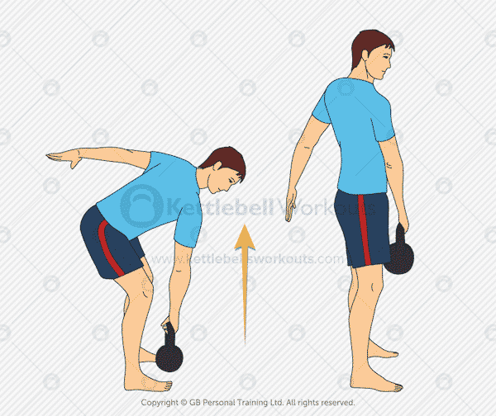

Muscles used: Back, Core, Glutes, Quads, Hamstrings  
Summary: Fundamental kettlebell exercise that strengthens most muscles in the body but in particular the Glutes, Hamstrings and Quads. An excellent starter exercise to practice before moving onto the kettlebell swing.

Kettlebell Single Leg Deadlift

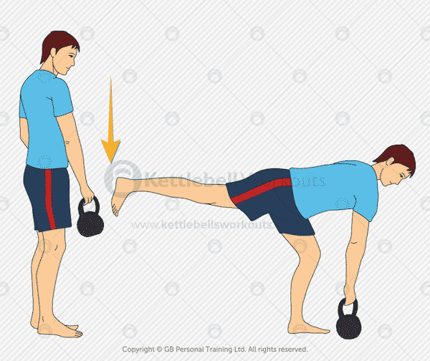

Muscles used: Back, Core, Glutes, Quads, Hamstrings  
Summary: A tricky exercise that will help to balance out the left and right side of your body. Excellent for working on your core muscles that connect your opposite shoulder to opposite hip.

Kettlebell Swing Two Hands

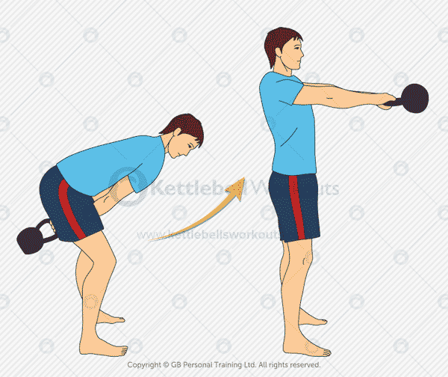

Muscles used: Shoulders, Back, Core, Glutes, Quads, Hamstrings  
Summary: The king of all kettle bell exercises. Works almost every muscle in your body without you having to even move your feet.

Kettlebell Single Handed Swing

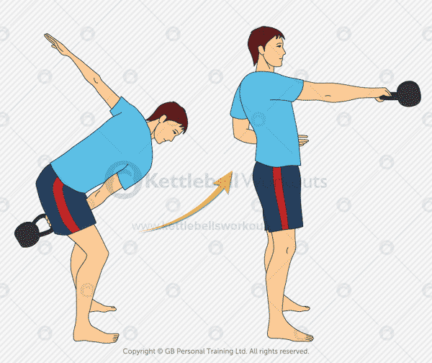  
Muscles used: Shoulders, Back, Core, Glutes, Quads, Hamstrings  
Summary: Slightly more challenging for your core muscles and shoulder stability than the two-handed swing. Tougher on your grip strength too!

Kettlebell Swing Changing Hands

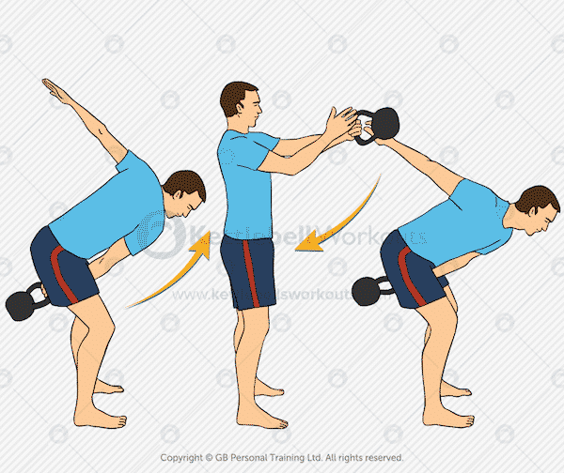  
Muscles used: Shoulders, Back, Core, Glutes, Quads, Hamstrings  
Summary: Keep the kettlebell moving from one hand to the other as you swing. Easier for your grip than the continuous one-handed swing.

Kettlebell Turkish Get Up

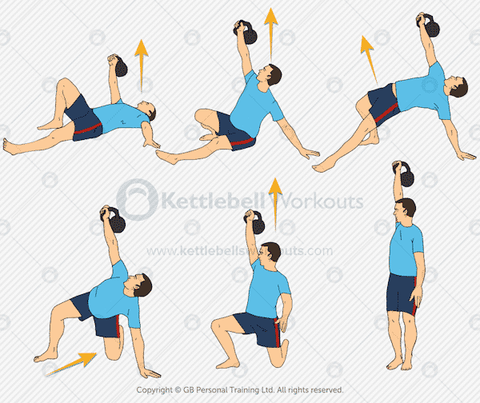

Muscles used: Shoulders, Core, Glutes, Quads, Hamstrings  
Summary: One of the most important kettle bell exercises. Challenge your core and mobility as you stand up and lie back down again, all while holding the kettlebell.

10Kettlebell Reverse Turkish Get Up

Muscles used: Shoulders, Core, Glutes, Quads, Hamstrings  
Summary: Rather than starting from the ground you begin standing up with this version of the Turkish Get Up.

Kettlebell Goblet Squat

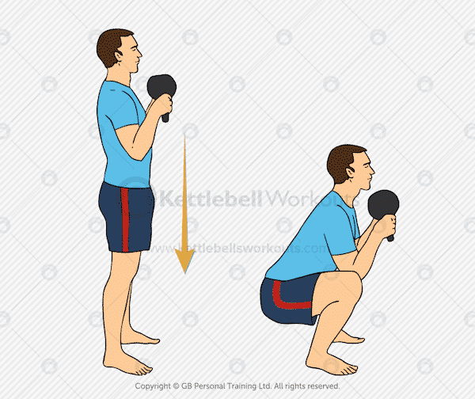

Muscles used: Shoulders, Core, Glutes, Quads, Hamstrings  
Summary: Holding the Kettlebell upside down you perform a regular squat. Brilliant kettlebell exercise that should not be avoided.

Kettlebell Racked Squat

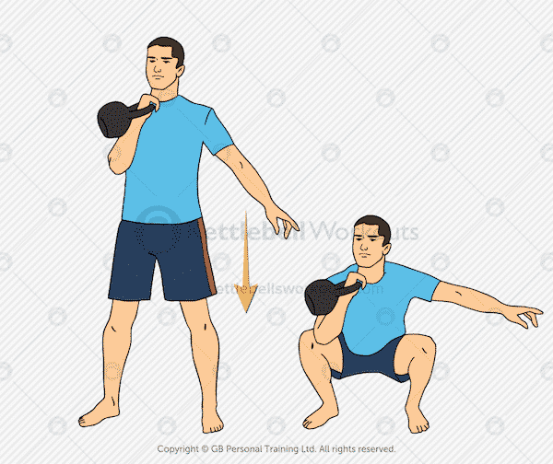

Muscles used: Shoulders, Core, Glutes, Quads, Hamstrings  
Summary: The same as a regular squat but holding the kettlebell with just one hand in the racked position.

Kettlebell Racked Reverse Lunge

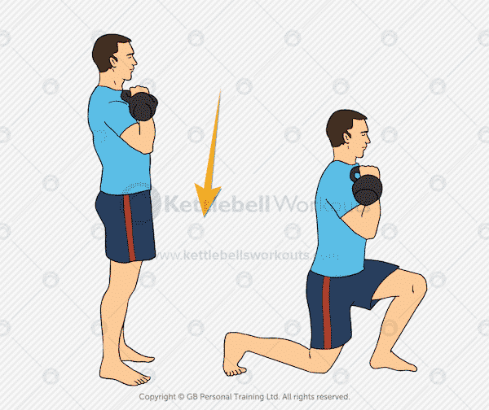

Muscles used: Core, Glutes, Quads, Hamstrings  
Summary: Fundamental exercise for your Buttocks that will also help improve your mobility too.

Kettlebell Regular Row

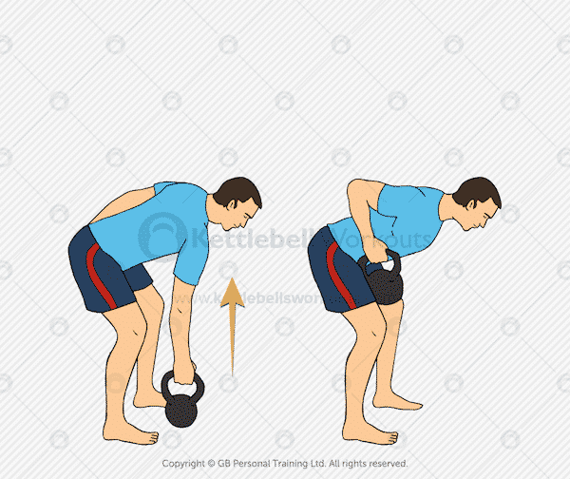

Muscles used: Shoulders, Biceps, Back, Core, Glutes, Quads, Hamstrings  
Summary: Works into the back of the upper body and is also challenging for the core muscles due to the rotational forces caused by the kettlebell.

Kettlebell Suitcase Row Exercise

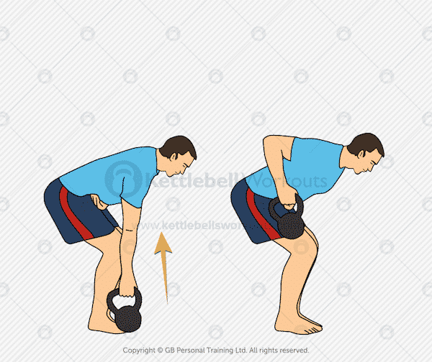  
Muscles used: Shoulders, Biceps, Back, Core, Glutes, Quads, Hamstrings  
Summary: A row performed at the side of the body. This row variation also focuses into the back of the shoulder.

Kettlebell Windmill

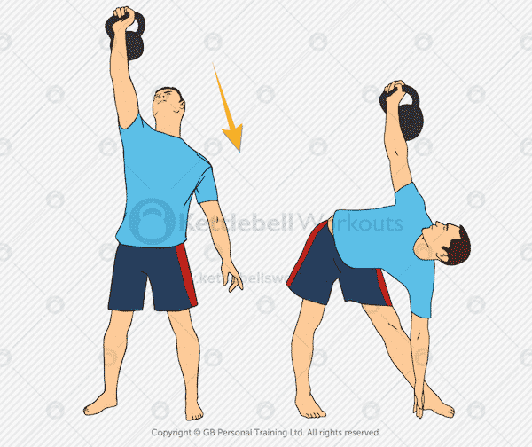

Muscles used: Shoulders, Core, Glutes, Hamstrings  
Summary: Improve your shoulder and hip mobility with this kettlebell exercise. Great for strengthening your core muscles too!

Kettlebell Overhead Warm Up

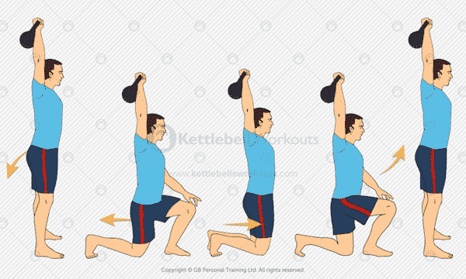  
Muscles used: Shoulders, Core, Glutes, Quads, Hamstrings  
Summary: Great way to improve your shoulder stability before you begin overhead pressing exercises.

Kettlebell Clean

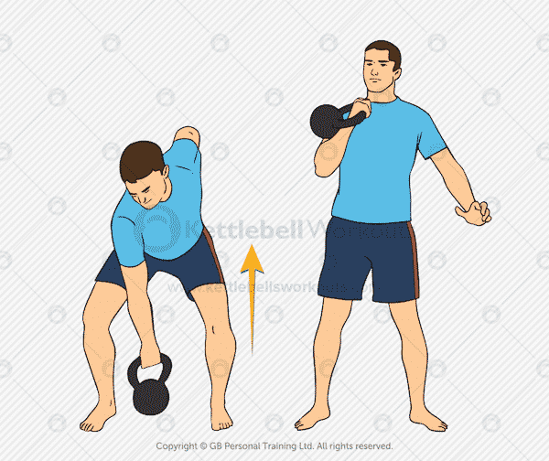

Muscles used: Shoulders, Back, Core, Glutes, Quads, Hamstrings  
Summary: The clean takes the kettlebell from the floor to the racked position in one smooth movement. When performed correctly this movement uses most muscles in the body.

Kettlebell Bottoms Up Clean

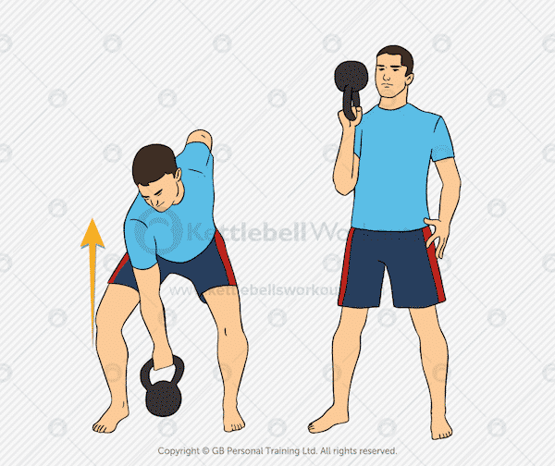  
Muscles used: Shoulders, Back, Core, Glutes, Quads, Hamstrings  
Summary: Improve your Clean technique and strengthen your wrists and core muscles with this exercise variation. Great as a warm up movement too!

Kettlebell High Pulls

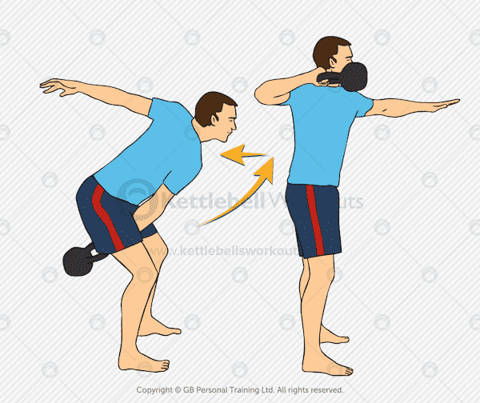

Muscles used: Shoulders, Back, Core, Glutes, Quads, Hamstrings  
Summary: Fast and dynamic this kettlebell exercise will elevate your heart rate quicker than almost all other exercises.

Kettlebell Bob and Weave

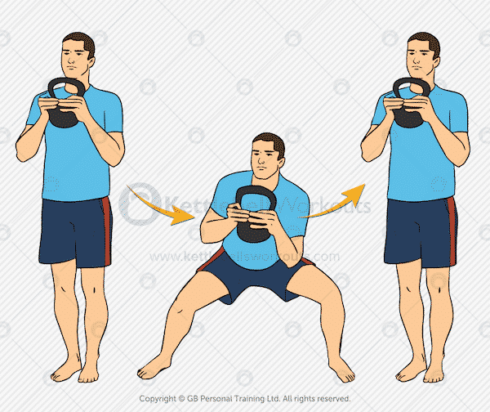

Muscles used: Back, Core, Glutes, Quads, Hamstrings  
Summary: Develop strength and flexibility with this lateral movement. Can be a very cardiovascular exercise too.

Kettlebell Side Lunge

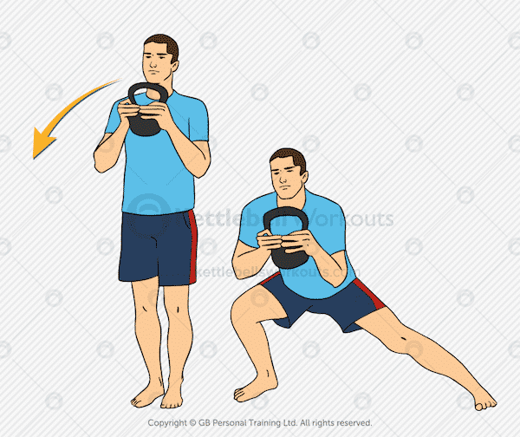

Muscles used: Back, Core, Glutes, Quads, Hamstrings  
Summary: Tough strength-based kettlebell exercise that will also improve your hip flexibility. Be careful to warm up well before going to deep with this movement.

Kettlebell Lunge with Rotation

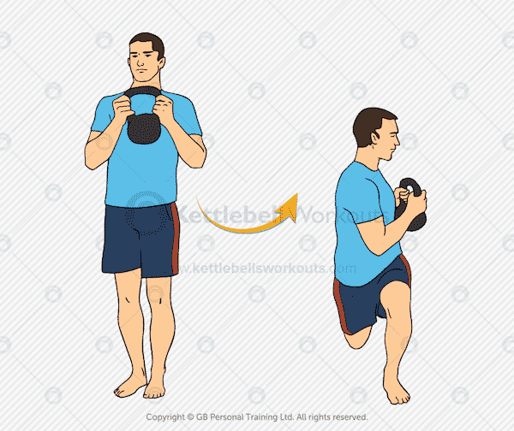

Muscles used: Shoulders, Core, Glutes, Quads, Hamstrings  
Summary: Excellent for improving your mobility and challenging your stability as you add a twist into the regular lunge.

Kettlebell Double Lunge

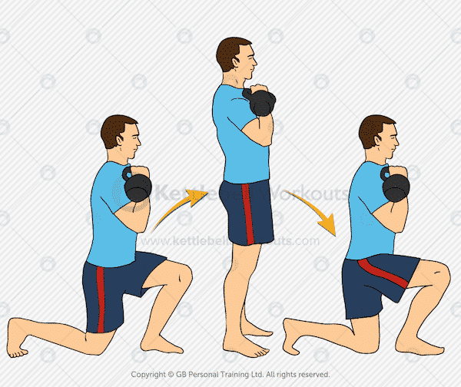  
Muscles used: Core, Glutes, Quads, Hamstrings  
Summary: Tough version of the lunge that really overloads the movement pattern. This exercise seriously raises your heart rate too.

Kettlebell Tall Kneeling Press

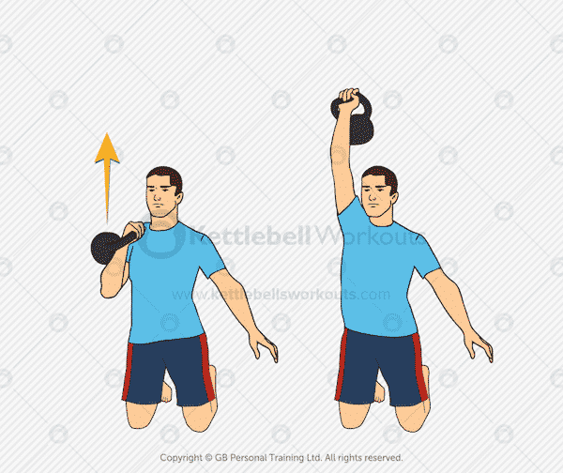  
Muscles used: Shoulders, Triceps, Glutes, Core  
Summary: Focus more on your shoulders by pressing from a double kneeling position. Great exercise for beginners.

Kettlebell Half Kneeling Press

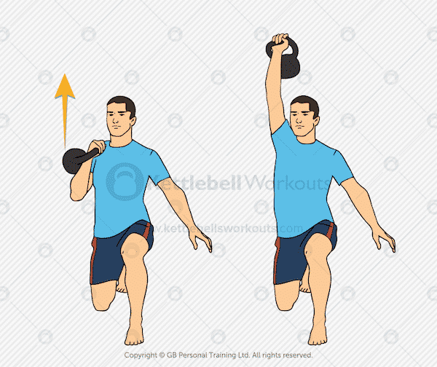

Muscles used: Shoulders, Triceps, Core, Glutes  
Summary: Challenge your core and Glute activation by pressing a kettlebell overhead while in the half kneeling position.

Kettlebell Overhead Press

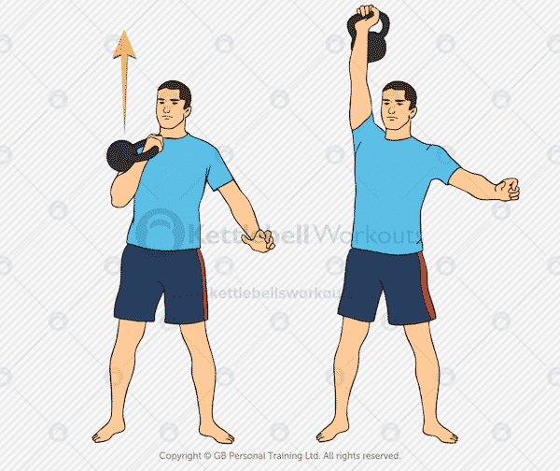  
Muscles used: Shoulders, Triceps, Core  
Summary: Brilliant kettlebell exercise for developing brute strength in the shoulder muscles. Keep your whole body tight for additional muscle activation.

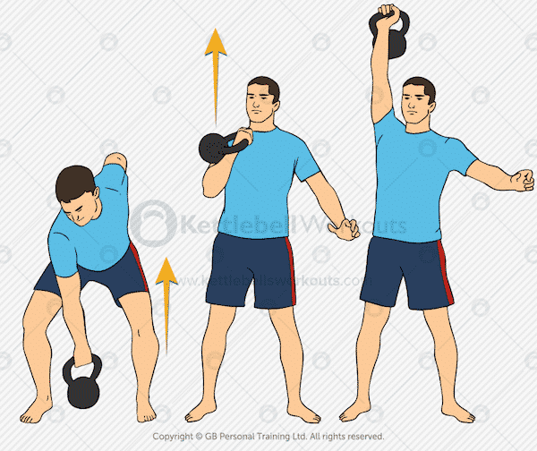Kettlebell Push Press

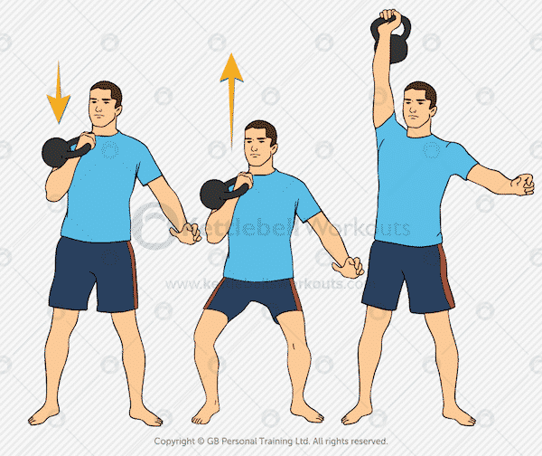  
Muscles used: Shoulders, Triceps, Core  
Summary: Help get the kettlebell out of the most difficult pressing position by using a push press. The push press is an excellent way to work on a heavy weight or continue to press when the shoulders get tired.

Kettlebell Clean and Press

Muscles used: Shoulders, Triceps, Back, Core, Glutes, Quads, Hamstrings  
Summary: Putting two of the big exercises together you achieve a movement that takes the kettlebell from the floor to the top of the press. Very challenging, full body exercise.

Kettlebell Clean and Push Press

Muscles used: Shoulders, Triceps, Back, Core, Glutes, Quads, Hamstrings  
Summary: If you struggle with the overhead press then you can make it slightly easier by adding a push into the movement to take the kettlebell out of the sticking point.

Kettlebell Two Handed Squat and Press

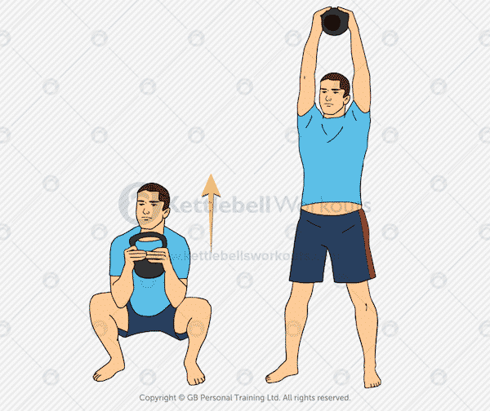  
Muscles used: Shoulders, Triceps, Core, Glutes, Quads, Hamstrings  
Summary: Very cardiovascular exercise that works most muscles of the body. A great progression after the Kettlebell Squat.

Kettlebell Thruster (Squat and Press)

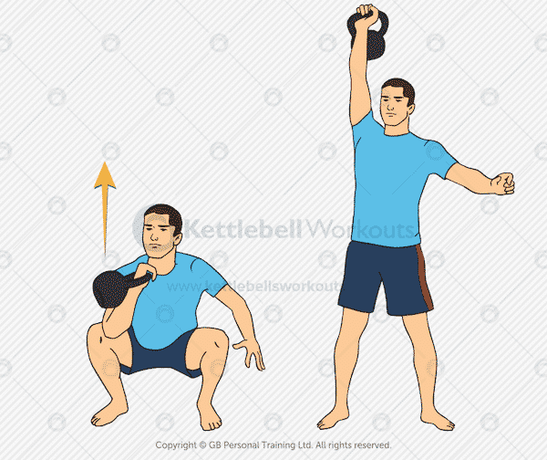

Muscles used: Shoulders, Triceps, Core, Glutes, Quads, Hamstrings  
Summary: Challenging exercise that will condition the body from head to toe as well as your heart and lunges.

Kettlebell Static Lunge and Press

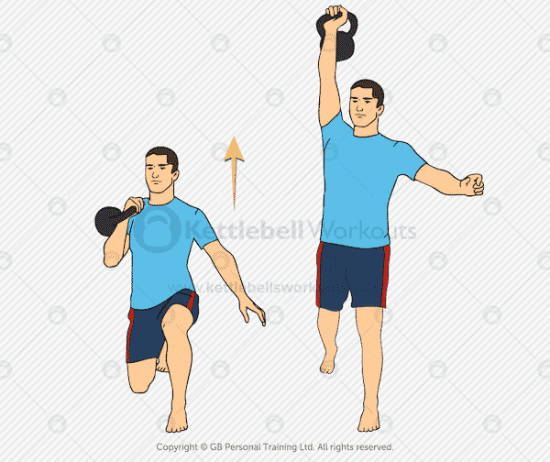

Muscles used: Shoulders, Triceps, Core, Glutes, Quads, Hamstrings  
Summary: During this kettlebell exercise your feet never move but you do overload the one side of your body. Great for improving your balance and stability too.

Kettlebell Lunge and Press

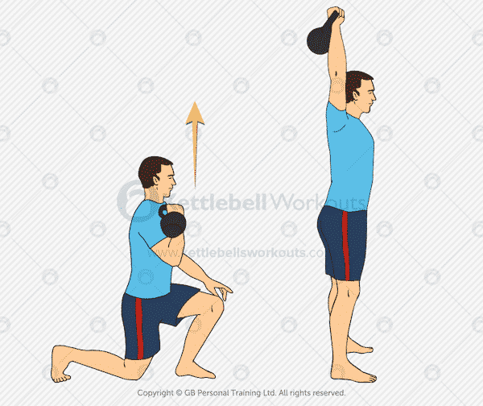

Muscles used: Shoulders, Triceps, Core, Glutes, Quads, Hamstrings  
Summary: More difficult variation of the lunge that works the upper body as well as the lower body. Get your heart and lungs ready for this one.

Kettlebell Clean, Squat and Press

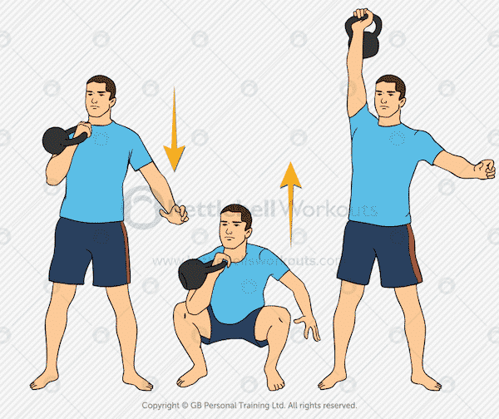  
Muscles used: Shoulders, Triceps, Back, Core, Glutes, Quads, Hamstrings  
Summary: Tough combination of moves that uses a double hip bend making the movement very demanding. Can take a little practice to remember the sequence of moves.

Kettlebell Overhead Reverse Lunge

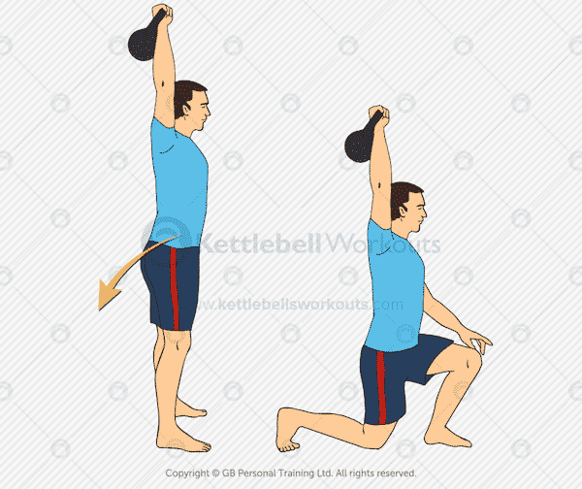  
Muscles used: Shoulders, Core, Glutes, Quads, Hamstrings  
Summary: Challenge your core muscles and shoulder stability as you perform the lunge while holding the kettlebell overhead. Make sure you always keep your arm locked for this exercise.

Kettlebell Overhead Walking Lunge

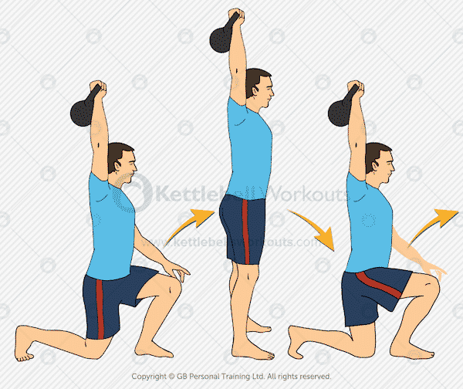  
Muscles used: Shoulders, Core, Glutes, Quads, Hamstrings  
Summary: Even more difficult than the variation above. The walking movement places even further demands on your core and shoulder stability.

Kettlebell Sit and Press

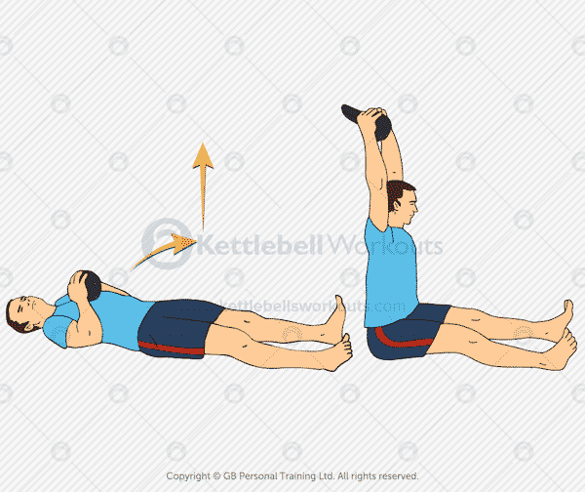

Muscles used: Shoulders, Triceps, Core, Glutes, Quads, Hamstrings  
Summary: Good shoulder exercise as well as developing your core and hip mobility. Ensure you come down nice and slowly after sitting up.

Kettlebell Snatch

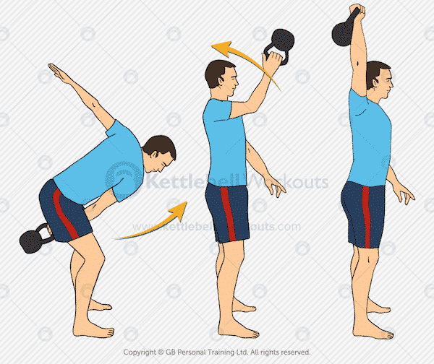

Muscles used: Shoulders, Back, Core, Glutes, Quads, Hamstrings  
Summary: Take the swing to a whole new level as your drive the kettlebell overhead using almost every muscle in your body. Requires good timing and a high level of kettlebell skill to master this exercise.

Kettlebell Renegade Row

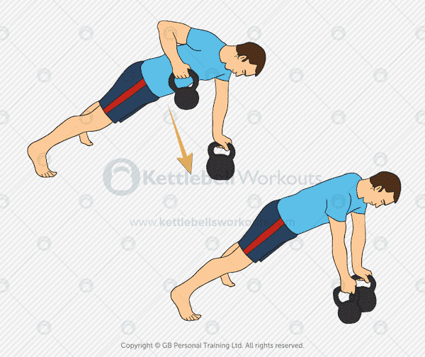

Muscles used: Shoulders, Biceps, Back, Core, Glutes  
Summary: Massive core exercise that also working into the back of the body too. Before even attempting this exercise, you should be able to perform a good solid plank for at least 60 seconds.

Kettlebell Side Stepping Swing

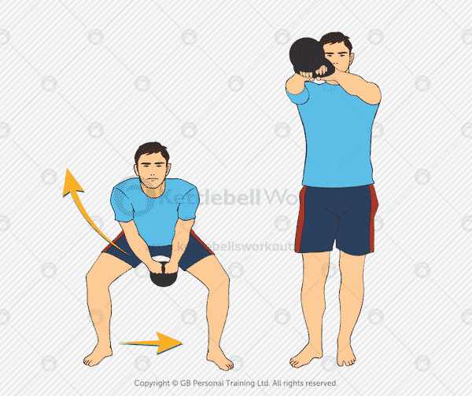  
Muscles used: Back, Core, Glutes, Quads, Hamstrings  
Summary: Start moving your feet as you swing to add another dimension to this classic kettlebell exercise. Requires good timing and the ability to swing well to perform this exercise safely.

Kettlebell Bottoms Up Press

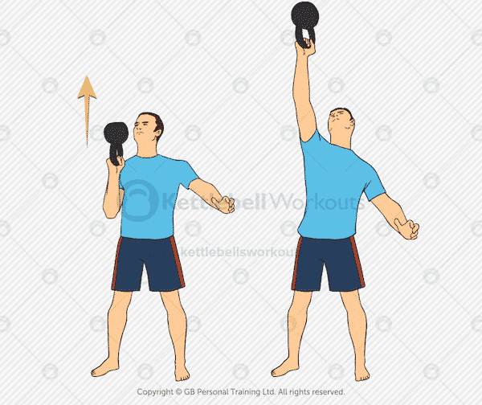

Muscles used: Shoulders, Triceps, Core  
Summary: Great core and grip strength as well as body alignment is needed to press the kettlebell overhead while in the upside-down position.

Kettlebell Farmers Carry

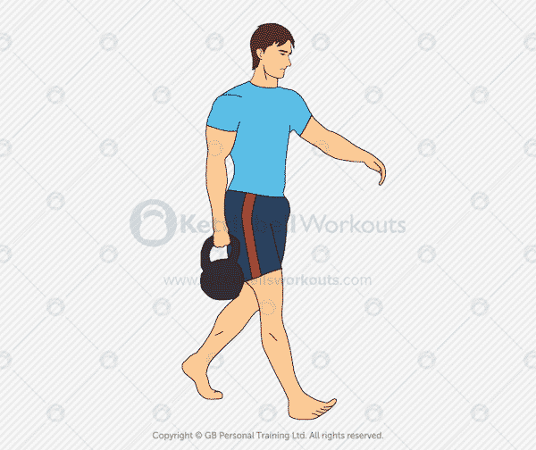

Muscles used: Shoulders, Obliques and core, Latissimus Dorsi, Trapezius, Forearms  
Summary: A very practical kettlebell exercise that works hard into the core muscles as the body tries to maintain upright alignment. Challenging on your grip strength.

Kettlebell Pistol Squat

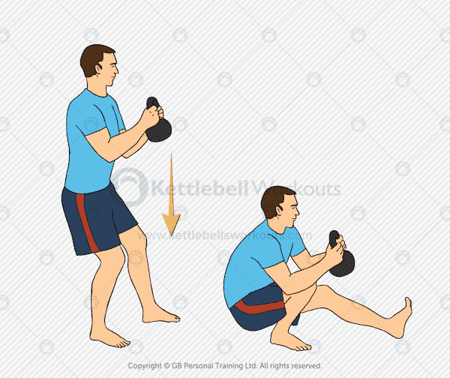

Muscles used: Shoulders, Core, Glutes, Quads, Hamstrings  
Summary: The ultimate leg exercise that will challenge your strength, flexibility and balance. One of my personal favorites!

Kettlebell Tactical Lunge

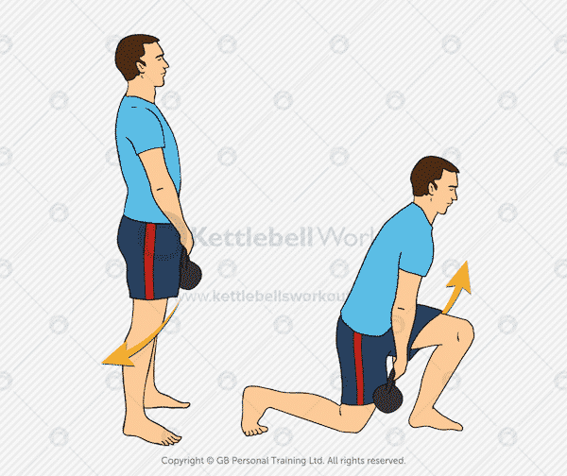  
Muscles used: Shoulders, Core, Glutes, Quads, Hamstrings  
Summary: Challenge the lunge movement pattern by passing the kettlebell between your legs during each step. Make sure you keep your core engaged and back flat throughout the movement.

Kettlebell Overhead Squat

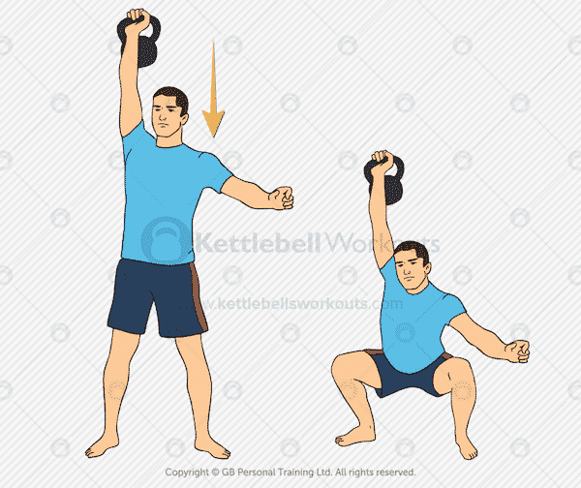

Muscles used: Shoulders, Core, Glutes, Quads, Hamstrings  
Summary: Tough kettlebell exercise that requires good shoulder and hip mobility as well as shoulder stability. Become great at the regular Squat and Press before taking on this exercise.

Kettlebell Straight Arm Sit

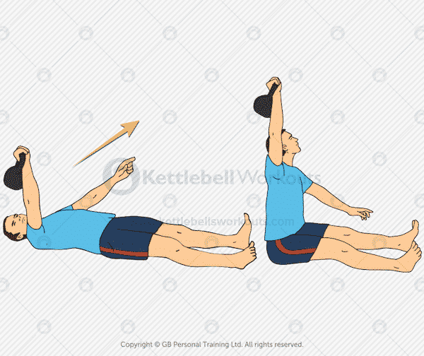

Muscles used: Shoulders, Core  
Summary: Big core exercise that requires good shoulder stability too. You can make the exercise easier by using the weight of the kettlebell to help pull you up.

Kettlebell Deck Squat

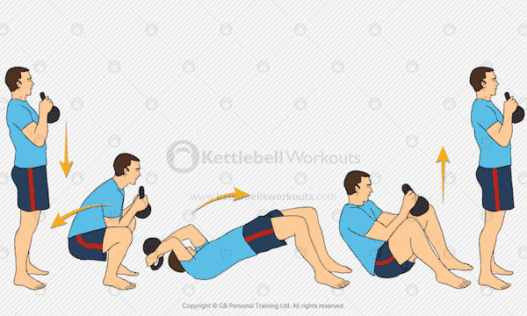

Muscles used: Shoulders, Back, Core, Glutes, Quads, Hamstrings  
Summary: A personal favorite of mine. You will need excellent hip mobility to enable you to get your hips underneath you on the way up from the bottom position.

Kettlebell One Legged Clean

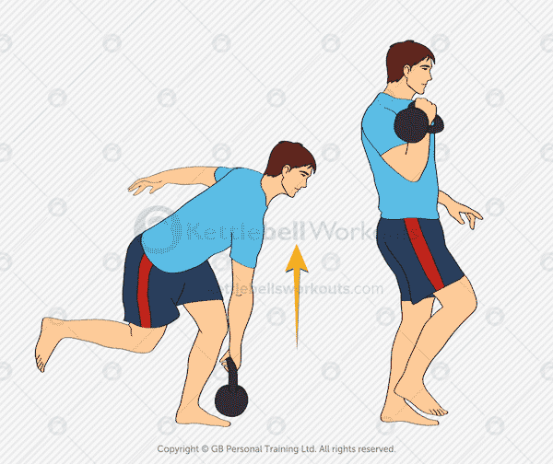

Muscles used: Shoulders, Back, Core, Glutes, Quads, Hamstrings  
Summary: Great for challenging your balance but more importantly your core strength as you clean the kettlebell standing on only one leg.

Kettlebell Side Lunge and Clean

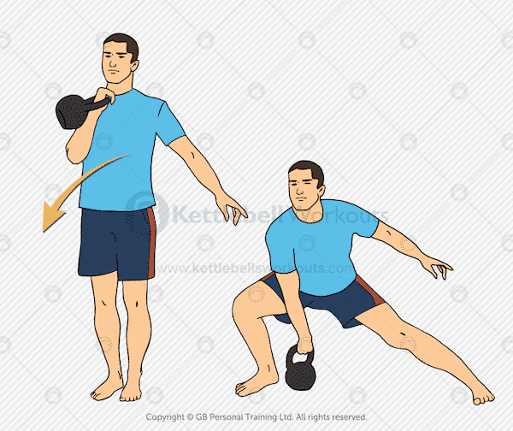  
Muscles used: Shoulders, Back, Core, Glutes, Quads, Hamstrings  
Summary: Funky kettlebell exercise that takes some getting used to. Once mastered it targets practically every muscle including your heart.

Kettlebell Hip Thrust

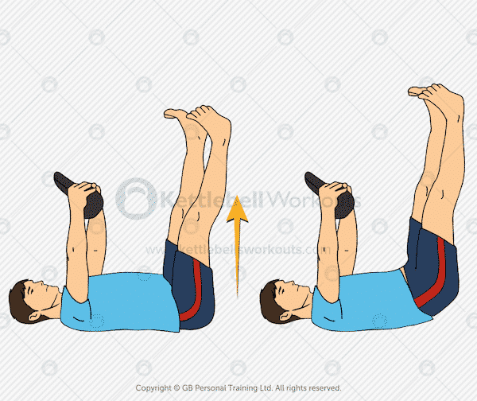

Muscles used: Core and Abs  
Summary: A core intensive kettlebell exercise that will help to mobilize the upper back and thoracic spine at the same time. Perform slowly with control.

Kettlebell Lateral Swings

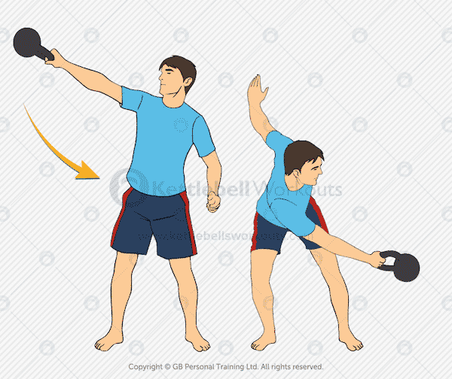  
Muscles used: Shoulders, Back, Core, Glutes, Quads, Hamstrings  
Summary: Very advanced kettlebell exercise that takes the swing to a new rotational level. Be super careful of your front knee as the kettlebell comes across your body.